Game Studies – Assignment 3:
Ionatan Biniamin Maghidman

Essay Prompt: Analyse the impact that game genres/tags have in the cultural discourse of games.
Introduction: Games as a medium are notorious for the adoption of internal references that acknowledge their own status as fictional, so much so that a dedicated genre has been established to group them under one umbrella term, “meta-games”, or metafictional games. Despite massive popularity, many people are not aware of this term, which in large part is a consequence of lack of acknowledgment from the stores that sell videogames. The inclusion of a tag that assembles games of this genre under one name in storefronts is not simply a commercially savvy initiative, but most importantly, one that leads to the development of game’s culture as a whole.
Argument 1: It is crucial to begin by defining metafiction, which will enable the demonstration of its relevance across many mainstream mediums with examples. Initially coined – and only briefly, with a single mention – by William H. Gass in his 1970 book, “Philosophy and the Form of Fiction”, the concept was further explored by Patricia Waugh in her book “Metafiction: The Theory and Practice of Self-Conscious Fiction” (1984). Waugh’s expanded description includes “fictional writing which self-consciously and systematically draws attention to its status as an artefact in order to pose questions about the relationship between fiction and reality” (Waugh 1984, p 2).
Although quite specific as a genre of media, the practice of creating metafictional material is widely popular and not exclusive to videogames, spanning throughout all forms of media. Leonard Cohen’s song “Hallelujah” (1984) describes the process of playing a song in the lyrics, explaining what chords are necessary as they are played. Andrew Niccol’s film “Truman Show” (1998) explores the process of filming a television series where the main actor is unaware of the fake and cinematic nature of the world he inhabits. Finally, Galactic Café's videogame “The Stanley Parable” (2013) follows the protagonist’s struggle against a narrator who attempt to impose a pre-ordained narrative, but affords the player the freedom to defy the game’s premeditated path.
It is evident that metafiction is a well-established idea not only in the academic world, but also in popular media, which consumers are familiar with even if at times only subconsciously, without deliberately attributing it to the name of “metafiction”. However, despite its popularity, major game storefronts seem unaware or disinterested in branding titles with this tag, meaning you are not able to browse videogames which share the same thematic of being self-referential, nor be recommended similar experiences by the store itself under this basis.
Ironically, a large enough group of people is aware of the concept of metafiction that if you attempt to find games of this genre on major search engines, such as Google, you can easily encounter what you are looking for, as evidenced in the images below. In other words, you are required to browse for the games of this particular type in external sources in order to later be able to buy them in the store that sells them, as opposed to just finding them in the internal store search engine. In summary, in terms of outreach, metafiction is sufficiently relevant to justify the creation of a dedicated tag that encompasses the games that have an element of self-reference.
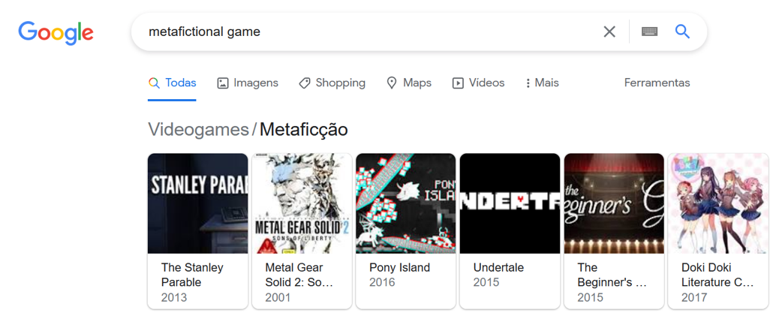
“Metafiction” results in Google, viewed at 21/05/2022.
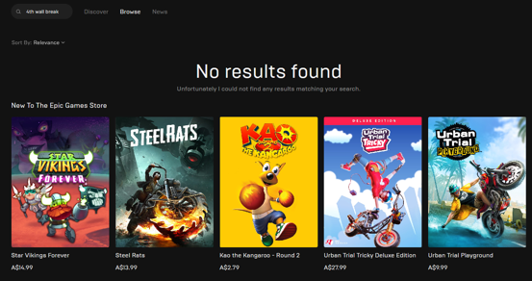
“Metafiction” results in Epic Games, viewed at 21/05/2022.
Argument 2: One may put forth the criticism that if it is so simple to find the answers on Google, then there is no point in establishing tags that englobe all the aforementioned games in one basket. That would be a reductive solution to the problem, which would not only overlook a series of prevalent issues, but would also miss great opportunities at opening discourse around the topic of metafiction. The first point that this critique disregards is the fact that a considerable number of people are unaware of the concept of metafiction whatsoever, not only the nomenclature, but also its conceptual significance. In this situation, someone who would be interested in this genre might be neglected the opportunity to experience games like this because they would have never been introduced to them in the first place, by extension, never having the idea to look for them in external search engines at all.
The second situation left unsatisfied by leaving it up to external search engines is when someone is aware of the concept of metafiction, but does not recognize it by this name. In this scenario, a person would know what they want to experience, but would have an incredibly frustrating experience attempting to explain what they are looking for, potentially to the point of being unable to find it. Steam for example, currently has a community driven tags system that somewhat approximates the description of metafiction, but no tag is specific enough to prevent some games from being left out. On the example below, I have compiled three games that although drastically different in genre and gameplay, all share their identity of metafictional pieces, and Steam clearly lacks an accurate descriptor term to unify them all:
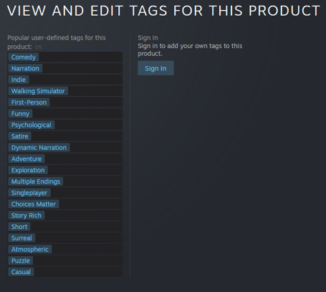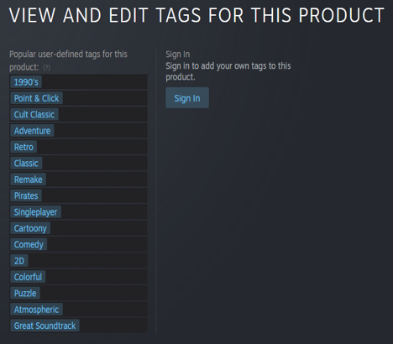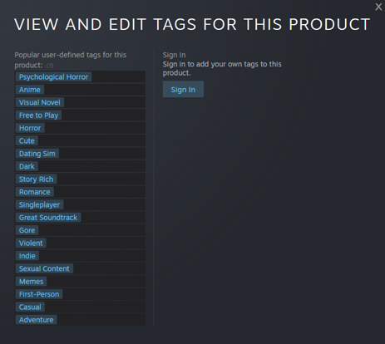Respectively, the tags of “The Stanley Parable” (2013), “The Secret of Monkey Island" (1990) and “Doki Doki Literature Club” (2017), all viewed at 21/05/2022.
Argument 3: The third aspect that would be neglected by a lack of the tagging of metafiction in game stores would be that there is a larger issue evoked from a severely impaired investment in Search Engine Optimization (SEO). This field of study is defined as “the science of customizing elements of your web site to achieve the best possible search engine ranking” (Ledford 2008, p 18). In the case of metafiction, as the author puts it (Ledford 2008), it is the search engine’s ability to discern games that belong in this specific category from the massive crowd of other unrelated games.
It is in the best interest of game distributors to fine tune their SEO quality because, as put forth by Bhandari and Bansal (2018), there are numerous noteworthy improvements in marketing effectiveness, such as “increase market share ( p-value = 0.3219), enhances the brand equity of the marketer (p-value = 0.0106) followed by other factors, that is, product awareness, purchase persuasion, and consumer insights” (Bhandari and Bansal 2018, p 35). Hence, from the perspective of the game stores, an optimized search engine leads to more impactful marketing, and therefore game sales.
Tag words are a key element of SEO, as stated by Jung and An (2021, p 3); “Each tag is a significant factor for optimizing SEs. The closer the term is to the beginning of the title tag, the more weight it has with SEs.” So much so that large marketing companies such as Straight North, Ignite Visibility, Boostability, and Twinword have voiced support for their adoption (Jung and An 2021). However, a tag that simply matches the term that was searched for is not the only factor that makes them useful in SEO. Tags are especially effective measurements because they take into account (Jung and An 2021) the “semantic relevance” of the term that was searched by comparing it with the content present in the body of text of what is found. As seen in the graph below, more efficient SEO strategies tend to land their results closer to the first available pages in the search engine because the term that was searched was positively correlated with the content that was offered on the website. In the same way, if tags were adopted with more precision in online game distributors’ storefronts, the chances of people finding games under a more niche tag, such as metafiction, would be much higher. Hence, from the consumer’s perspective, the incentive for better quality SEO investment would be the enhancement of their ability to find new titles, and more broadly, genres that they will deem relevant to their personal preferences in gaming.
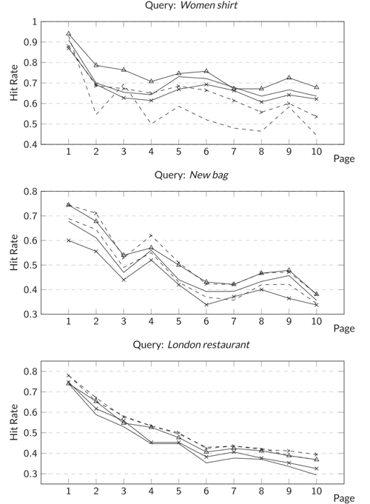
(Jung and An 2021, p 7) “FIGURE 2 Hit Rates of Terms' combination for Websites on each
Page according to Weighting Factor.”
It is worth noting that the current most notorious online game distributors, such as Steam and Epic Games already have tag systems implemented, which are ran in part by the customer’s input, since users are responsible for categorizing games through their own opinion. With a large enough portion of the community mutually denominating the game in a specific tag, the more likely it is for the tag in question to become official in the game’s store page, therefore visible for other consumers. The fatal flaw of this system is that it is only partially “community powered” as opposed to what is stated in Steam’s own storefront (Steam, 2014). Users can only attribute tags from a pre-existing list, meaning that there is no way to voluntarily categorize niche interests that are not present. This was not initially the case (Ontd Games, 2014), but the feature enabling new user generated tags to be created was severely dampened in response to mass scale online trolling from users who blatantly mischaracterized games with often inappropriate and offensive nomenclature. Despite the fact that Steam’s current tag system works as intended in both grouping similar games as well as recommending them to keen customers in cases of commonplace interests, such as “racing” or “FPS”, more specific genres fall in the depths of neglect.
Argument 4: The goal in meticulously deconstructing the technical SEO related advantages of making more comprehensive tags is not to simply justify why this is a profitable opportunity that mutually benefits stores and their users. The goal of pushing harder for the adoption of more comprehensive lesser-known tags such as metafiction is so that the general public attaches a label term to its corresponding concept. This affords people the cultural opportunity to more accessibly discuss and contribute to the topic via mainstream formats, by referring to it by name in game journalism websites, YouTube, live streams, etc. The potential for the popularization of niche tags consequentially grows, eventually seizing their status as niche and becoming a mainstream interest, and by extension, growing popular demand for games and other medium forms that incorporate the current highly circulated trend at hand. Proportionately, as the demand for games around a trending topic grows, game developers will realize this to be an opportunity as a creative outlet to develop new content that meets the desires of the public. Hence, a rise in popularity leads to high demand from the public, which leads to game developers meeting the demands, which in turn makes the genre even more popular, in a mutually beneficial positive feedback loop.
An example that demonstrates the potential for niche topics to rise the ranks of popular discourse was the gradual and still ongoing growth of the idea of “liminal spaces”. Originally defined by Arnold van Gannep in his book “The Rites of Passage” (Gannep, Vizedom, Caffee, 2010), liminal spaces are a highly conceptual idea that applies to any physical or metaphorical space of transitory status, where one inhabits with the intent of moving from a previous space onto a new one. Despite its academically niche nature and a time gap of over one hundred years since it was first introduced in the beginning of the twentieth century in 1909, liminal spaces have gone on to become a trend in recent years due to the rise of COVID-19, as seen in the graph below at the start of 2020. In response to the isolation imposed by quarantine, the masses have attached the term of liminal spaces to a less broad notion, more focused in the concept of spaces that make you feel nostalgia or recognition of a location that you are unable to fully pinpoint, but many of which still hang on to the original meaning of spaces that demonstrate passage, such as bridges, airports or corridors.
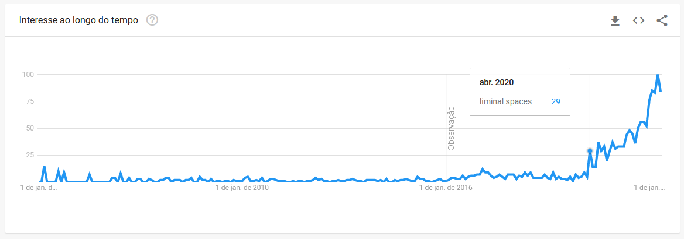
Google Trends search for “liminal spaces", viewed on 24/05/2022.
The case study of “liminal spaces” is proof that despite adversities, a niche topic can become a relevant area of main stream attention, to the point where a considerable number of people have developed content which expands upon this cultural phenomenon in the many avenues of the internet, most notably video essays on YouTube, forum generated lore that expands the universe of liminal spaces, and above all in this case, games that allow you to explore liminal spaces. If the same treatment that has been given to liminal spaces was given to metafiction, perhaps there could be a day where it too grows in the hierarchy of popularity, and people begin to yearn for its discussion in social media, and to look for new content covering its expansion.
Argument 5: However, it is crucial to highlight the fact that this particular parallel drawn between liminal spaces and metafiction is not exclusive to them. This comparison can be modularly replaced with any number of other equally valid, small niche interests that do not have a corresponding tag present in game stores. Acknowledging the possibility that many other genres have the room to grow and flourish into full blown cultural phenomena is a fantastic affordance for online game stores, who will profit from it, but mainly to customers, who will be afforded new creative outlets. Additionally, the chances of each individual niche interest to mature on their own merit would not be as high as the prospect of appealing to various niche audiences simultaneously. In other words, in isolation, perhaps one niche audience would not stand a chance to amount to a large cultural wave, but by appealing to a plethora of niche audiences, altogether, one can garner the attention of many new players for new games, making it a more appealing move for commercially driven game stores. Hence, despite this essay’s contention surrounding the genre of “metafiction”, the same argument applies to any other niche filter/game genre that is not included in game stores widely.
Conclusion: Metafiction is a popular topic, but whose name has not been associated with its corresponding concept. This is an issue that should not be disregarded under the basis that tools external to game environments already are capable of finding them. Aside from being economically unwise for storefronts, limiting the comprehensiveness of niche tags dampens the opportunity to popularize them into mainstream interest. By extension, many great cultural opportunities to further expand the vocabulary of the game’s community are missed, due to a lack of connection drawn between niche concepts and their corresponding name tag, therefore hindering the creative potential of game creators. Hence, the reason for fostering the growth and maintenance of good tagging practices in stores is both an economic and cultural effort.

References:

Waugh, Patricia 1984. Metafiction: the Theory and Practice of Self-Conscious Fiction. London ;: Methuen. Web.
Ledford, Jerri L 2008. SEO: Search Engine Optimization Bible. Hoboken, N.J: Wiley. Print.
Bhandari, Ravneet Singh, and Ajay Bansal 2018. “Impact of Search Engine Optimization as a Marketing Tool.” Jindal Journal of Business Research 7.1: 23–36. Web.
An, Sojung, and Jason J. Jung 2021. “A Heuristic Approach on Metadata Recommendation for Search Engine Optimization.” Concurrency and computation 33.3: n. pag. Web.

Steam (2014) " Introducing Steam Tags, A Powerful New Way to Shop For Games". Available at: https://store.steampowered.com/tag/ (Accessed: 22 May 2022).

Ont Games (2014) “Valve Introduces User-Generated Steam Tags (and it's already a disaster)
” Available at: https://ontdgames.livejournal.com/267907.html (Accessed: 22 May 2022).
Gennep, Arnold van, Monika B. Vizedom, and Gabrielle L. Caffee (2010). “The Rites of Passage”. Trans. Monika B. Vizedom and Gabrielle L. Caffee. London: Routledge. Print.

